**535/1**

**PHYSICS**

Paper1

**July / Aug. 2019**

2 hours 15 minutes

Name of School:……………………………………………………..............................…….

Name of Student:………………………………………………..............................…...……

Signature:……………………….....….......……**Personal No**.……............…………………



**JOINT MOCK EXAMINATIONS 2019**

**Uganda Certificate of Education**

PHYSICS

**Paper 1**

2 hours 15 minutes

**INSTRUCTIONS TO CANDIDATES:**

Section **A** contains **40** objective type questions. You are required to write the correct answer, **A**, **B**, **C** or **D** in blue or black ink against each question in the box on the right hand side.

Section B contains 10 structured questions. Answers are to be written in the spaces provided on the question paper.

Mathematical tables and silent non-programmable calculators may be used.

Acceleration due to gravity, g = 10 ms-2

Specific heat capacity of water = 4200 Jkg-1K-1

Specific latent heat of vaporization of water = 2.3 x 106 Jkg-1

**For Examiners’ Use Only**

|  |  |  |  |  |  |  |  |  |  |  |  |
| --- | --- | --- | --- | --- | --- | --- | --- | --- | --- | --- | --- |
| **Q.41** | **Q.42** | **Q.43** | **Q.44** | **Q.45** | **Q.46** | **Q.47** | **Q.48** | **Q.49** | **Q.50** | **MCQ** | **Total** |
|  |  |  |  |  |  |  |  |  |  |  |  |

**Turn Over**

1. The following are fundamental quantities except;
2. Quantity of charge
3. Luminous intensity
4. Quantity of heat
5. Length

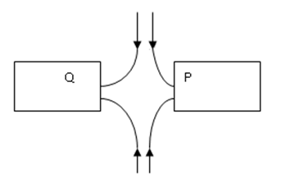2. The figure below shows two bar magnets

Name the poles of Q and P of the bar magnets shown in figure above.

Q P

1. North North
2. South South
3. North South
4. South North

3. A solid weighs 7N in air and 3N when completely immersed in water. If the density of water is 1000kgm-3, determine the density of the solid in kgm-3.

1. 1700
2. 1750
3. 1800
4. 1900

4. In a wet Leclanché cell, the carbon powder:

1. Increases the conducting surface of the carbon rod.
2. Connects the carbon rod to the zinc rod.
3. Acts as an electrolyte.
4. Prevents polarization.

5. One of these can give a uniform electric field:

A. an isolated point positive charge.

B. an isolated point negative charge.

C. two point charges of opposite nature near each other.

D. two plates of opposite charges near each other.

6. Like poles of a magnet

A. like each other.

B. attract each other.

C. oppose each other.

D. collide with each other.

7. The diagrams below show traces of a cathode beam on the screen of a CRO when there is no input on the Y plates and time base is on.

A

B

C

D

8. The function of a lens in a CRO is carried out by

A. the anodes.

B. the control grid.

C. deflecting system.

D. the electron gun.

9. Conduction of heat takes place

A. through solids only.

B. through gases only.

C. through solids and liquids only.

D. through solids and gases.

10. The temperature at which all energy is removed from a substance is

A. its freezing point.

B. its melting point.

C. zero degrees Celsius.

D. absolute zero temperature.

11. At terminal velocity,

A. a body has zero velocity.

B. a body has zero displacement.

C. a body has zero acceleration.

D. a body has zero weight.

12. Stress is

A. too much work.

B. force x area.

C. strength.

D. force over area.

13. A red dress with green stripes in blue light will appear

A. blue.

B. blue with yellow stripes.

C. black.

D. red with blue stripes.

**Turn Over**

14. This is not a reason for using a convex mirror as a driving mirror:

A. it gives upright images.

B. it has a wide field of view.

C. it gives only virtual images.

D. all its images are behind the mirror.

15. A bulb rated 4v works at maximum capacity at a power of 6W. Its resistance is

A. 1.5Ω.

B. 2.67Ω.

C. 90.0Ω.

D. 2400Ω.

16. A household uses 12 bulbs each rated 100W for three hours a day for five days. How many units does it use?

A. 1.2 x 3 x 5

B. 

C. 12 x 3 x 100 x 5.0

D. 

17. One of these is the odd man out.

A. Nickel

B. Cobalt

C. Iron

D. Copper

18.

Volume

t

Temperature (oC)

The figure above shows the volume of water as it is cooled. The temperature is

1. 0
2. 100oC
3. 37oC
4. 4oC

19. A fish in water attains a wide field of view due to

A. refraction only.

B. total internal reflection.

C. reflection only.

D. interference.

20. One of these does not change when a wave moves from deep to shallow water.

A. Amplitude

B. Frequency

C. Wavelength

D. Period

21. One of these is an isotope of .

A. 

B. 

C. 

D. 

22. A newton is defined as

A. the S.I unit of force.

B. a force that accelerates a body at 1ms-2.

C. a force that accelerates a 1kg mass at 1sm-2.

D. a force that decelerates any body at 1ms-2.

23. An elastic body under deformation possesses

A. kinetic energy.

B. potential energy.

C. electrical energy.

D. heat energy.

24. Loudness of sound depends on

A. amplitude.

B. velocity.

C. frequency.

D. wavelength.

25. A girl at a distance of 340m from a tall wall heard her echo 2s after clapping. What is the speed of sound in air?

A. 85ms-1

B. 170ms-1

C. 340ms-1

D. 510ms-1

26. Sound can be heard more clearly at night than during day due to

A. reduction in noise.

B. interference.

C. refraction of sound towards the ground.

D. diffraction.

**Turn Over**

27. In photoelectric effect the rate at which electrons are produced is

A. increased as light intensity is increased.

B. decreased as light intensity is increased.

C. not affected by increases in light intensity.

D. not important.

28. One of these graphs shows the motion of a body thrown vertically upwards.

Velocity

Velocity

Velocity

Velocity

Time

Time

Time

Time

A

B

C

D

29. Cooling fins in a refrigerator are hot due to

A. heat from electricity.

B. latent heat of vaporization from the gas.

C. friction from the gas.

D. friction from the pump.

30. The velocity ratio for a gear train with a driving wheel of 20 teeth and driven wheel of 8 teeth is

A. 0.4.

B. 28.

C. 12.

D. 2.5.

31. A convex lens can be used as a telescope when the object is

A. at infinity.

B. at F.

C. between C and F.

D. at C.

32. The image formed by a plane mirror is

A. real and upright.

B. real and the same size as the onject.

C. real but laterally inverted.

D. upright and same size as the object.

33. These rays are used in florescent tapes.

A. Gamma

B. X-rays

C. W-rays

D. Rooho-waves

34. This is not an example of a connection current.

A. See breeze

B. Land breeze

C. House ventilation

D. Floating of ice on water.

35. Friction

A. is inversely proportional to the load.

B. is inversely proportional to the area of contact.

C. is directly proportional to the area of contact.

D. is independent of area of contact.

36. Centripetal force

A. increases with increase in the radius.

B. increases with increase in speed.

C. increases with a decrease in mass.

D. is determined by the direction of motion.

37. The earth behaves as if it contains a short but very strong bar magnet with

A. its north pole in the southern hemisphere.

B. its north pole in the east.

C. its north pole in the west.

D. its north pole in the northern hemisphere.

38. This is potential difference.

A. 

B. Charge x Work done

C. 

D. Work done + Charge

**Turn Over**

39. Electric transmission is done at a very high voltage to

A. avoid danger to humans.

B. avoid power loss.

C. avoid use of very expensive wires.

D. avoid use of transformers.

40. The frequency of vibration of a string is determined by

A. length only.

B. length and tension only.

C. length, tension and thickness.

D. none of these.

**SECTION B**

Answer **all** questions in this section. All working **must** be shown clearly in the spaces provided

41. (a) What is a harmonic? (**01 Mark**)

……………………………………………………………………………………………………

……………………………………………………………………………………………………

(b) Determine the frequency of the second over time of a closed pipe of length of 24cm given speed of sound in air is 320ms-1. (**03 Marks**)

……………………………………………………………………………………………………

……………………………………………………………………………………………………

……………………………………………………………………………………………………

……………………………………………………………………………………………………

……………………………………………………………………………………………………

42. (a) Define the term ‘internal resistance’ with respect to a cell. (**01 Mark**)

……………………………………………………………………………………………………

……………………………………………………………………………………………………

(b) A cell of internal resistance, r, and emf E gives a current I = .12A when connected to a one ohm resistor and a current I = 0.4A when connected to a four ohm resistor. Determine the value of E. (**03 Marks**)

……………………………………………………………………………………………………

……………………………………………………………………………………………………

……………………………………………………………………………………………………

……………………………………………………………………………………………………

……………………………………………………………………………………………………

……………………………………………………………………………………………………

……………………………………………………………………………………………………

……………………………………………………………………………………………………

43. (a) State one use of the following;

(i) x-rays (**01 Mark**)

……………………………………………………………………………………………………

(ii) cathode rays (**01 Mark**)

……………………………………………………………………………………………………

(b) List down the energy changes that take place in an X-ray tube. **(02 Marks)**

……………………………………………………………………………………………………

……………………………………………………………………………………………………

**Turn Over**

44. (a) State the principle of moments. (**01 Mark**)

……………………………………………………………………………………………………

……………………………………………………………………………………………………

(b) The diagram below is of a uniform meter rule is pivoted at the 20 cm mark.

200N

0cm 20cm

100 cm

When a force of 200N acts on it at the 100 cm mark, the metre rule remains in a horizontal position. Find the weight of the metre rule.

……………………………………………………………………………………………………

……………………………………………………………………………………………………

……………………………………………………………………………………………………

……………………………………………………………………………………………………

45. (a) What is heat capacity? **(01 Mark)**

……………………………………………………………………………………………………

……………………………………………………………………………………………………

(b) Determine the temperature rise of a substance of 500g and specific heat

capacity 400Jkg-1K-1 and heat capacity of heat is of 800J of heat supplied to it. **(03 Marks)**

……………………………………………………………………………………………………

……………………………………………………………………………………………………

……………………………………………………………………………………………………

……………………………………………………………………………………………………

……………………………………………………………………………………………………

……………………………………………………………………………………………………

……………………………………………………………………………………………………

46. (a) What is Brownian motion? **(01 Mark)**

……………………………………………………………………………………………………

……………………………………………………………………………………………………

(b) An oil drop of volume 103cm3 forms an oil patch of 0.785cm2 on water. Estimate the size of the oil molecule. (**03 Marks**)

……………………………………………………………………………………………………

……………………………………………………………………………………………………

……………………………………………………………………………………………………

……………………………………………………………………………………………………

……………………………………………………………………………………………………

……………………………………………………………………………………………………

……………………………………………………………………………………………………

……………………………………………………………………………………………………

……………………………………………………………………………………………………

47. (a) A stone weighs 12N in air, 9N in water and 8N in a liquid X. Determine the Rd of X. (**01 Mark**)

……………………………………………………………………………………………………

……………………………………………………………………………………………………

……………………………………………………………………………………………………

……………………………………………………………………………………………………

**Turn Over**

(b) Give a reason for the shape of each of the parts of a hydrometer:

(i) Stem **(01 Mark)**

……………………………………………………………………………………………………

……………………………………………………………………………………………………

(ii) the bulb (**01 Mark**)

……………………………………………………………………………………………………

……………………………………………………………………………………………………

(iii) the lead shut (**01 Mark**)

……………………………………………………………………………………………………

……………………………………………………………………………………………………

48. (a) Draw a diagram to show reflection of light from the focal point of a parabolic

mirror. (**02 Marks**)

(b) Use the diagram to explain why this mirror can be used as a car headlamp. **(02 Marks)**

……………………………………………………………………………………………………

……………………………………………………………………………………………………

……………………………………………………………………………………………………

……………………………………………………………………………………………………

49. (a) State the law of **electrostatics.** **(01 mark)**

……………………………………………………………………………………………………

……………………………………………………………………………………………………

(b) A small metal sphere carrying a positive charge is lowered gently into a metallic can placed on the cap of an uncharged gold leaf electroscope as shown below.

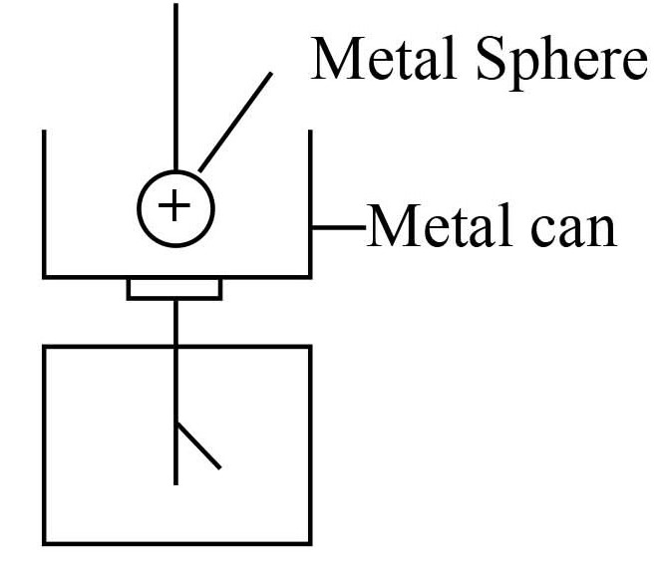

(i) State what happens to the leaf of the electroscope. **(01 mark)**

……………………………………………………………………………………………………

……………………………………………………………………………………………………

(ii) Explain the observation in *(*b) (i) above. **(02 marks)**

……………………………………………………………………………………………………

……………………………………………………………………………………………………

……………………………………………………………………………………………………

……………………………………………………………………………………………………

……………………………………………………………………………………………………

50. (a) What is a **neutral point** as related to an electric field? **(01mark)**

……………………………………………………………………………………………………

……………………………………………………………………………………………………

**Turn Over**

(b) State **three** properties of electric field lines. **(01½ marks)**

……………………………………………………………………………………………………

……………………………………………………………………………………………………

……………………………………………………………………………………………………

(c) Explain what happens when an ebonite rod is rubbed with fur. **(01½ marks)**

……………………………………………………………………………………………………

……………………………………………………………………………………………………

……………………………………………………………………………………………………

……………………………………………………………………………………………………

……………………………………………………………………………………………………

……………………………………………………………………………………………………

**End**